b

**A Lenten Journey to the Resurrection**

[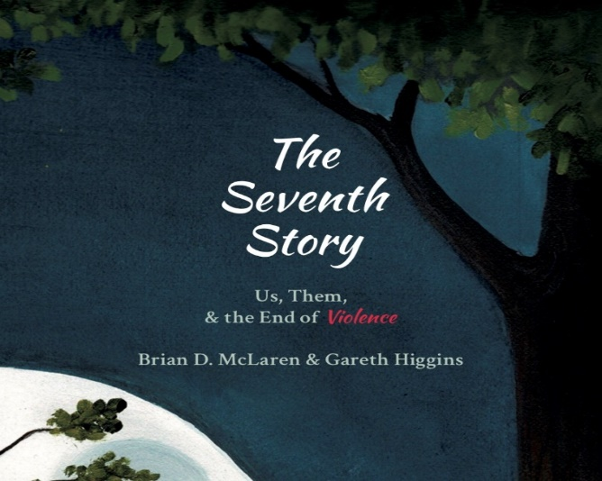](https://www.google.com/url?sa=i&rct=j&q=&esrc=s&source=images&cd=&cad=rja&uact=8&ved=2ahUKEwiwg4bKrM3gAhWQCDQIHQAOAtkQjRx6BAgBEAU&url=https%3A%2F%2Fwww.theseventhstory.com%2Fkids&psig=AOvVaw2W8-ObUPni8Yo2ecBXmCBJ&ust=1550856295438954)

**Wednesdays   
March 6th- April 17th   
9:30 – 11:30 am  
Located at St. Edmund’s  
Light Refreshment  
A Program of Spirituality Beyond Borders  
*By Donation*  
Presented by The Rev. Christine Muise  
For more information   
call 250-248-3114 email:parksville.anglican@gmail.com**

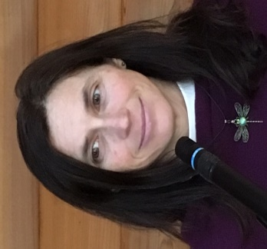 **Based on the Book By:  
 Brian D. McLaren & Gareth Higgins**

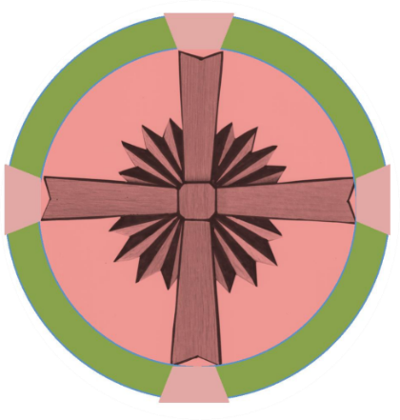

We’re living in a time of great upheaval, anxiety, and challenge: as well as great possibility, and even hope. We’re following the traditions of authentic spirituality to embrace Lent as a season for going deeper amidst the swirl of life. **The best way to respond to something bad is to do something better, so we’re taking a journey together for the 40 days of Lent**, seeking ancient wisdom about a better story: moving from oppositional energy to creative hope, from fear to faith, from distraction to contemplation, from individualism to the common good. We’re inviting you into conversations about what we call the Seventh Story: transcending domination, revenge, isolation, purification, victimization and accumulation narratives with a new story of reconciliation – humans with each other, with the ecosystem, and with **Love** **itself.**