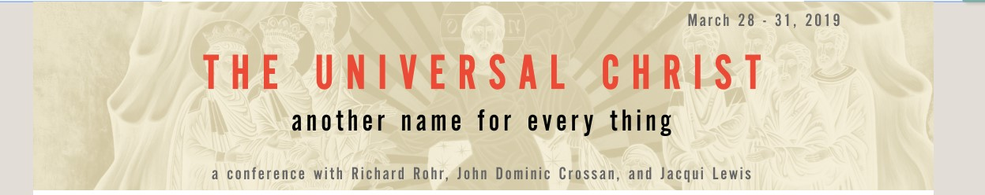0

**The Universal Christ: another name for every thing**

a satellite conference and webcast-in-community ~ featuring Richard Rohr, Jacqui Lewis,  
 & John Dominic Crossan

1. [Spirituality Beyond Borders](https://www.oneopencircle.org/collections/spirituality-beyond-borders)
2. The Universal Christ: another name for every thing

**The Universal Christ  
 another name for every thing**

*a satellite conference and webcast-in-community, from the Center for Action and Contemplation   
 (cac.org)*  ***~ featuring Richard Rohr, Jacqui Lewis, John Dominic Crossan~***

**Dates:**  **March 28th-March 31st, 2019**

**On-site welcome**:  **Thursday, March 28th ~ 11.00 am - 1:00 pm**

**Program Start-Time**:   **Thursday, March 28th, 1:00 pm**

**Cost**:  ***by donation***

**Location:**  at **St. Edmund's,  407 Wembley Rd, Parksville, BC**

**Pre-Registration**:        register your interest by email -- [***spiritualitybeyondborders@gmail.com***](mailto:spiritualitybeyondborders@gmail.com)  
 You are registering for a community experience in Parksville, BC, of a CAC conference being webcast from Albuquerque, New Mexico.   edited recordings of the event become available for purchase at a later date, after the conference.

Inquiries**:       email us:  spiritualitybeyondborders@gmail.com -- or leave a message at (250) 248-3114**

*Spirituality Beyond Borders ~ offering an experiential interface and Canadian West Coast destination for interactive satellite-campus webcasts and contextualized CAC program experiences, in partnership with*The Center for Action and Contemplation. *(cac.org)*

